📊 SALES DATA ANALYSIS PROJECT REPORT


Overview
This project analyses a retail sales dataset to understand customer behaviour, product performance, seasonal trends, payment preferences, and revenue patterns.
The raw data was first stored in a staging table (sales inf) and then normalized into a star schema consisting of:
- Dimension tables (Customer, Product, City, Season, Shipping, Payment).
- A central fact table (fact sales).

This approach improves:

- Data consistency.
- Query performance.
- Business reporting accuracy

Data Preparation & Cleaning
The company collects sales data related to customers, products, locations, seasons, and payment methods.
However, the data is stored in a single raw table, making it difficult to analyse sales performance, customer behaviour, and product trends efficiently.
Management currently lacks clear visibility into:

- Which products and categories generate the highest revenue
- How customer demographics affect purchasing behaviour
- Seasonal trends influencing sales
- The impact of subscription status on customer spending
- Preferred shipping and payment methods

Because of this, decision-makers are unable to optimize marketing strategies, inventory planning, and customer retention efforts.

WHAT’S HAPPENING

Currently, all sales-related data is stored in one unnormalized table where customer details, product information, and transaction data are repeated for every record.

This leads to:
- High data redundancy
- Increased risk of data inconsistency
- Slower query performance
- Difficulty in performing advanced analysis
Any change in customer or product information requires updating multiple records, increasing the possibility of errors and making data maintenance inefficient.

SOLUTION GOAL

The goal of this project is to:
- Clean and standardize the raw sales data
- Normalize the data into dimension tables and a fact table
- Reduce redundancy and improve data integrity
- Enable efficient SQL analysis and reporting
- Extract actionable insights for business decision-making
By implementing a normalized database design, the organization can analyse sales trends, customer behaviour, and product performance more effectively.

DATA DESCRIPTION

Title: Sales Data Analysis Dataset
- Records: ~3900 sales transactions
- Attributes: 13 columns
- Data Type: Mixed – Numerical and Categorical
Source Description
The dataset represents retail sales transactions capturing customer details, product information, purchase behaviour, and payment preferences. Each record corresponds to a single purchase made by a customer.

Key Fields in the Raw Dataset
- Customer Details:
customer id, age, gender, subscription status, previous purchases
- Product Information:
product name, category
- Transaction Details:
purchase amount, review rating
- Geographical & Time Attributes:
location, season
- Logistics & Payment Information:
shipping type, payment method

DATA CLEANING

1. Data Cleaning
Before normalization, the following cleaning steps were applied:
- Removed duplicate and inconsistent records using DISTINCT
- Standardized text values (using TRIM and LOWER) to avoid mismatch during joins.
Ensured correct data types:
- Numerical fields for purchase amount and ratings.
- Categorical fields for gender, season, payment method, etc.
- Verified subscription status values (Yes / No) for consistency.
- Checked for missing or invalid values before inserting into dimension tables.
These steps ensured data consistency and accuracy before database normalization.

DATA MODEL
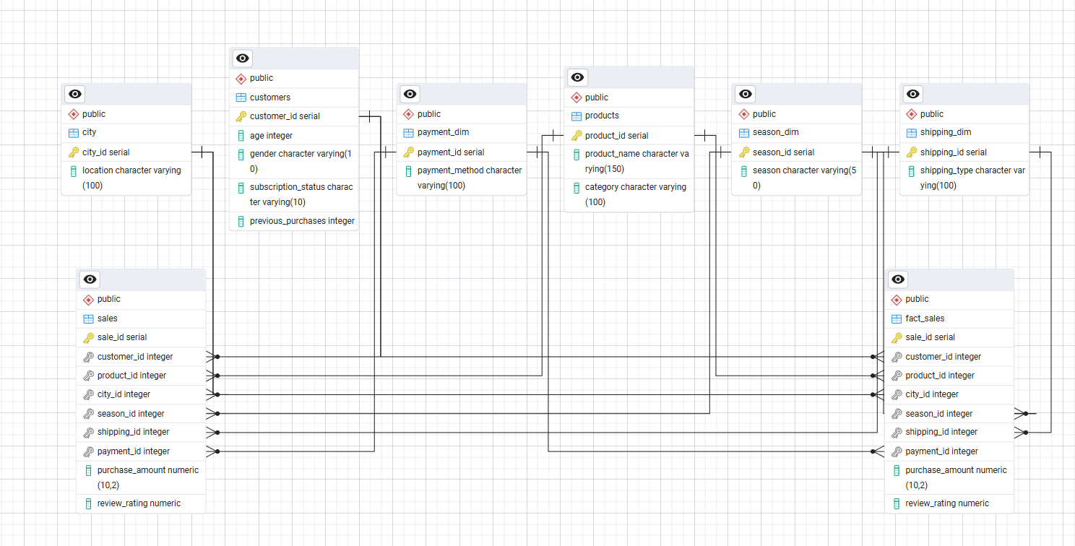
The data model follows a star schema design with one fact table (fact sales) and multiple dimension tables (customers, products, city, season dim, shipping dim, payment dim).
The fact table stores sales measures such as purchase amount and review rating, while dimension tables store descriptive details about customers, products, location, season, shipping, and payment methods.
Each dimension has a one-to-many relationship with the fact table, enabling efficient analysis of sales performance, customer behaviour, and trends.

Category 1. Sales Performance Analysis.
1.What is the total revenue generated by the company?

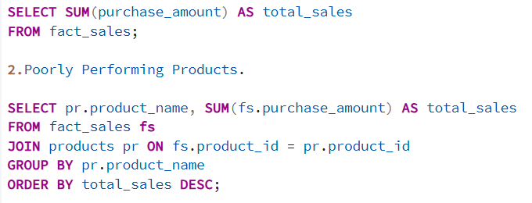
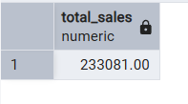
Insight:
This query calculates the overall sales value, providing a high-level view of business performance. It serves as a baseline metric to evaluate growth, profitability, and the impact of strategic decisions.

2.Which products generate the highest and lowest sales revenue?


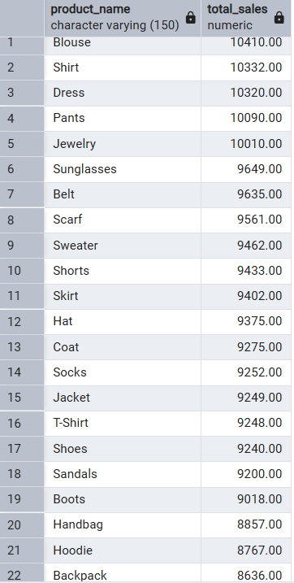
Insight:
Products are ranked by total sales amount, helping identify top-performing products and underperforming products. Low-selling products may require pricing adjustments, promotions, or discontinuation.

Category 2. Product & Category Analysis.
3.Which product categories receive the highest and lowest number of orders?

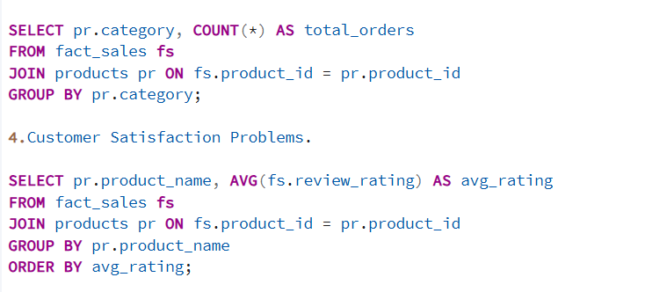
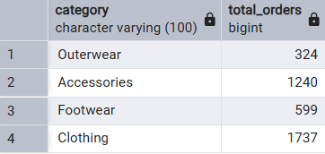
Insight:
This analysis highlights demand distribution across categories. Categories with fewer orders may need better marketing or product diversification, while high-demand categories may require inventory scaling.

4.How do customer ratings vary across products?

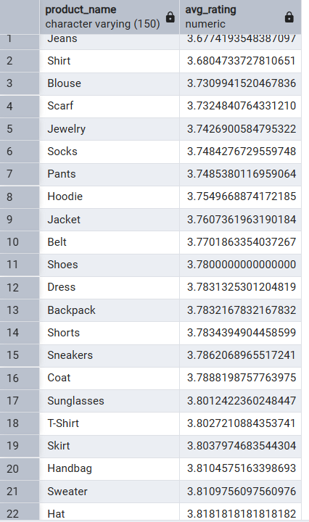
Insight:
Average product ratings reveal customer satisfaction levels. Products with low ratings indicate potential quality or service issues that should be addressed to improve customer experience and retention.

Category 3. Time & Seasonal Analysis.
5.How does sales performance change across different seasons?
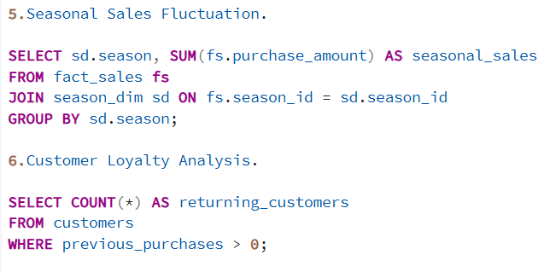
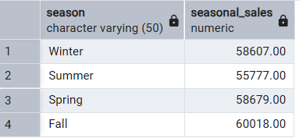
Insight:
Season-wise sales show seasonal demand patterns, helping management optimize inventory planning, staffing, and seasonal promotions.

Category 4. Customer Behaviour & Loyalty Analysis.
6.How many customers are returning buyers?

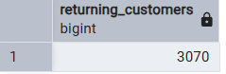
Insight:
Identifies loyal customers who have made previous purchases. A higher number of returning customers reflects strong customer retention, while low numbers signal the need for loyalty programs.

7.How many customers are subscribed to the service?
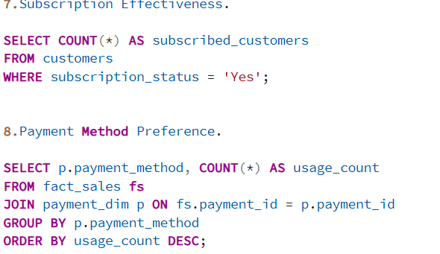
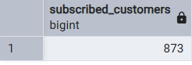
Insight:
This analysis measures subscription adoption, indicating whether subscription offerings are attractive and effective in retaining customers.

Category 5. Payment & Operations Analysis
8.Which payment methods are most commonly used by customers?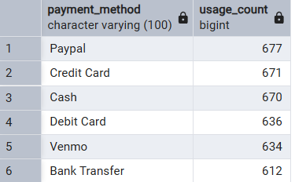
Insight:
Understanding payment preferences helps optimize checkout experiences, reduce transaction failures, and prioritize popular payment options.

Category 6. Demographic-Based Sales Analysis.
9.How do sales differ by customer gender?

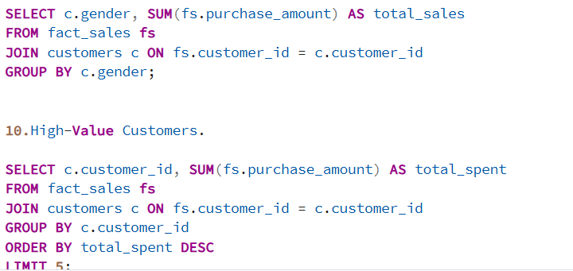
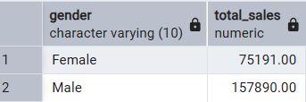
Insight:
This analysis highlights gender-based purchasing behaviour, enabling more personalized marketing strategies and targeted promotions.

category 7. Customer Value Analysis
10.Who are the top customers contributing the highest sales revenue?



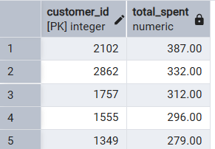
Insight:
Identifies high-value customers who contribute disproportionately to total revenue. These customers should be prioritized for retention, personalized offers, and loyalty incentives.

Recommendations
- Focus marketing on top-selling products and categories.
- Improve or phase out low-performing products.
- Enhance customer experience for products with low ratings.
- Prepare inventory and promotions according to seasonal demand.
- Implement loyalty programs to increase repeat customers.
- Promote subscription plans to boost adoption.
- Optimize checkout with preferred payment methods.
- Use demographic insights (e.g., gender) for targeted marketing.
- Engage and reward high-value customers.

Conclusion
The analysis shows overall strong sales with clear high-performing products and loyal customers. Addressing low-performing products, seasonal fluctuations, and customer satisfaction issues can further boost revenue. Targeted marketing, improved customer engagement, and efficient inventory planning will help sustain growth and profitability.

